**STYLES**

**BOOK DETAILS**

1: Adding a style to footer.

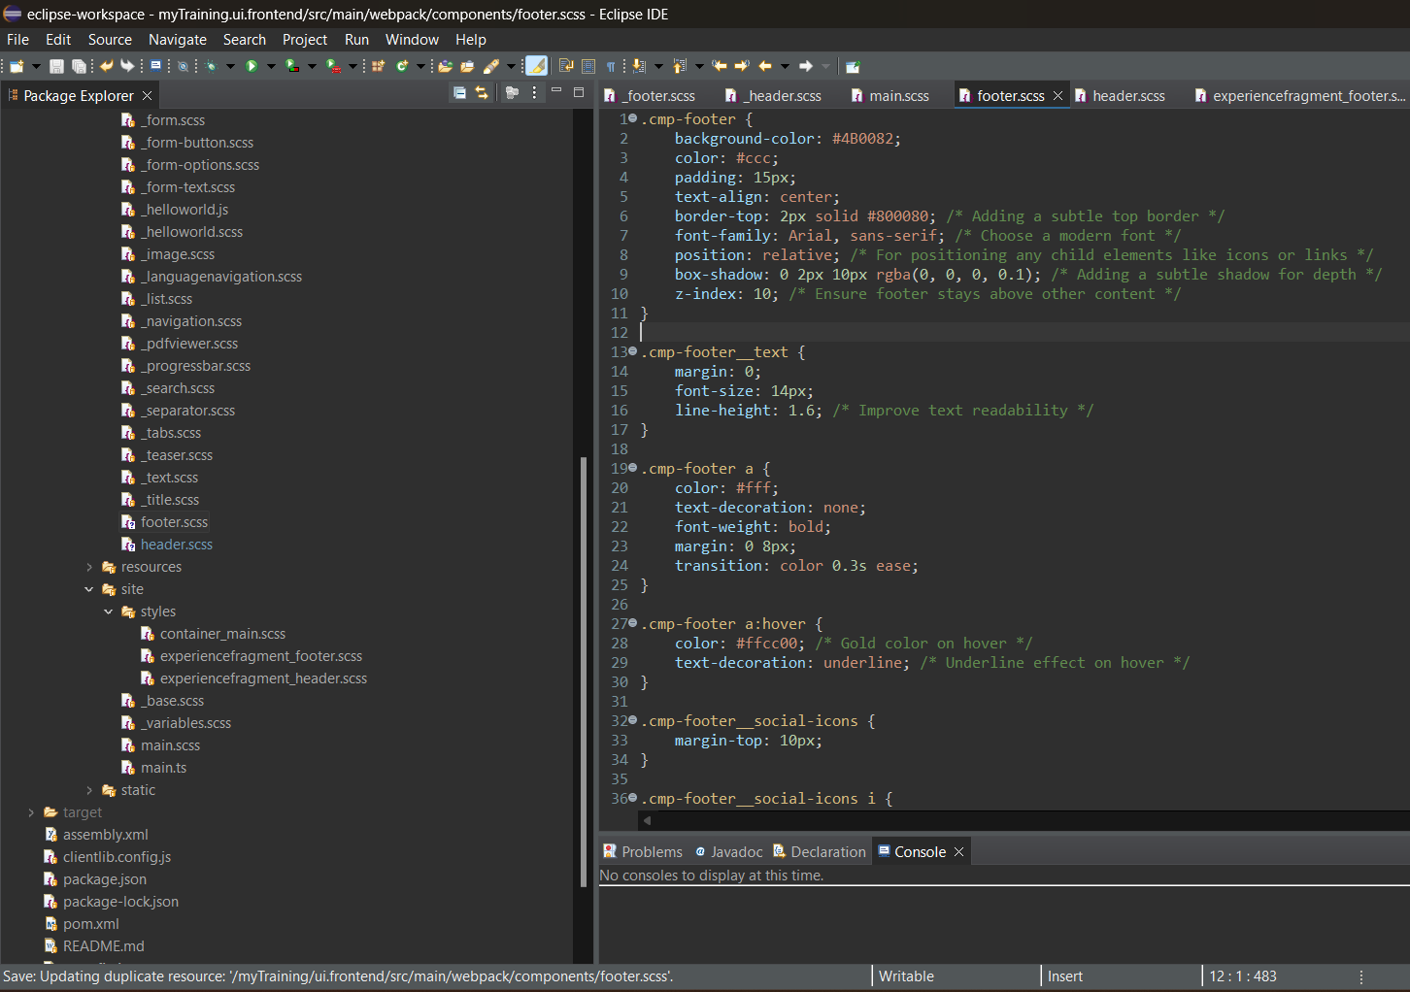

2: Adding a style to header.

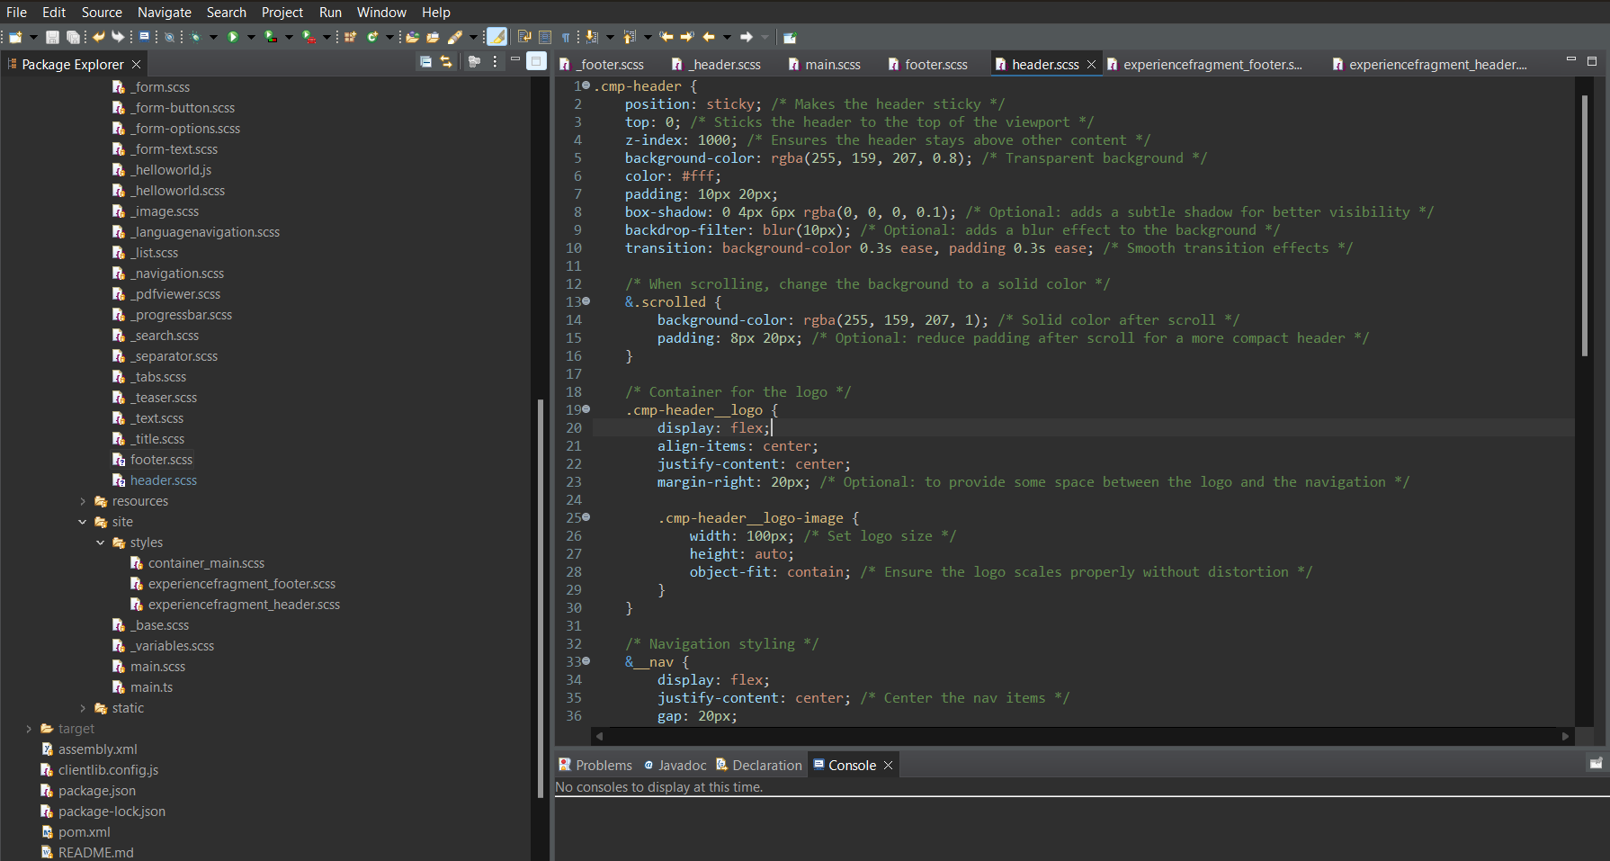

3: Adding script

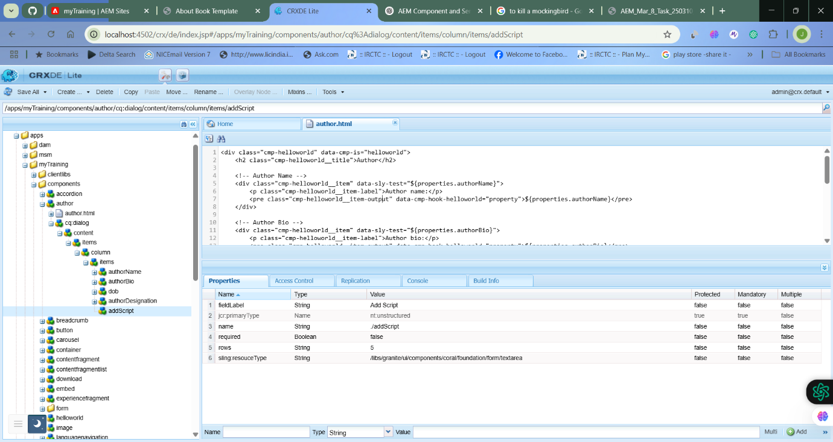

OUTPUT:

**BOOK PAGE:**

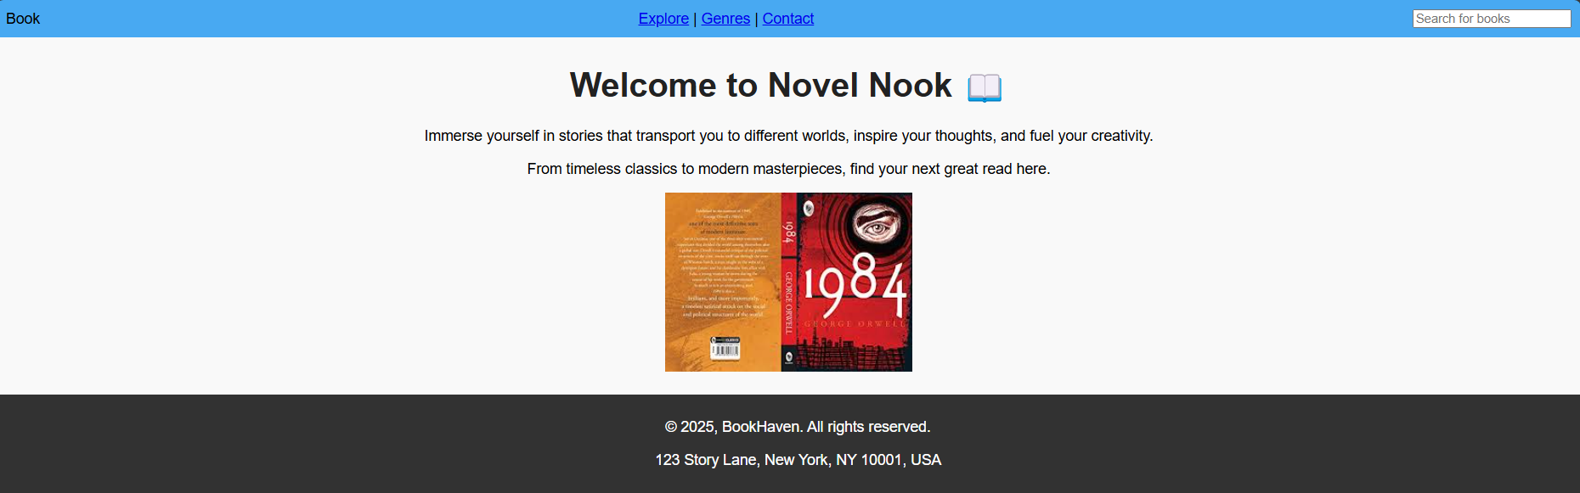

**ALL BOOKS PAGE (HOME PAGE)**

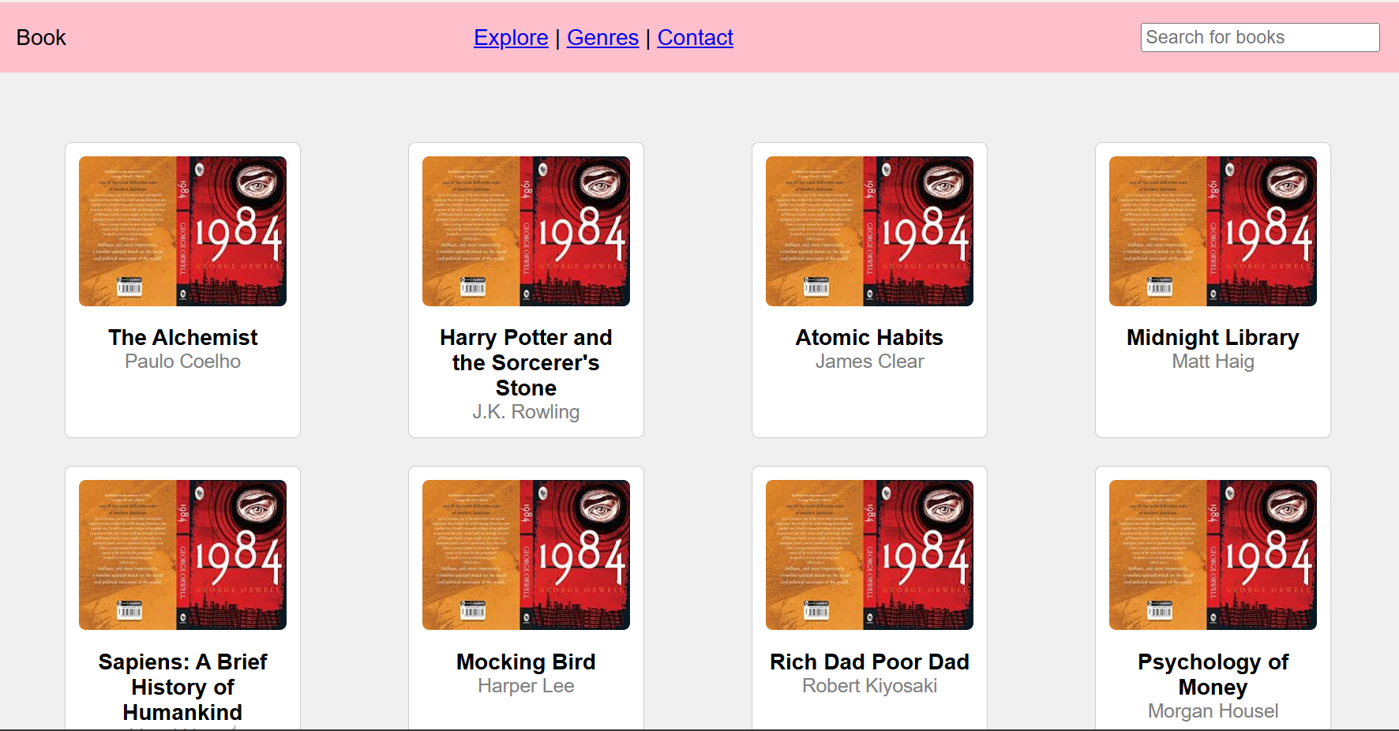

**ATOMIC HABITS:**

